NATIONAL UNIVERSITY OF MODERN LANGUAGE ISLAMABAD
OEL


Submitted to:
Ms. Fatima Gillani
Submitted by:
Zulqarnain Hassan
Roll No: …………………… SP21379
Subject: …………………… SCD
Department: ……………… BSSE-5-Afternoon
Date: ……………………… 05-12-2024

Task 1
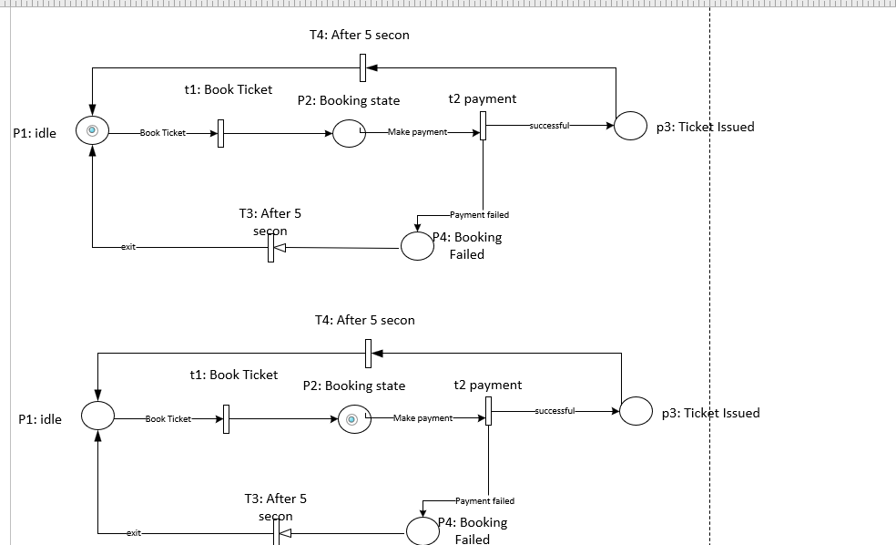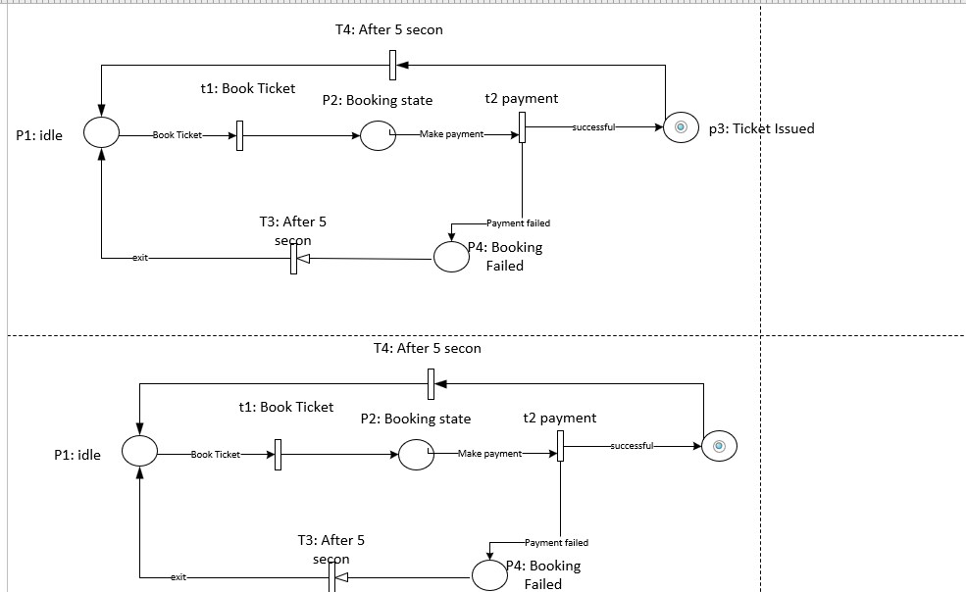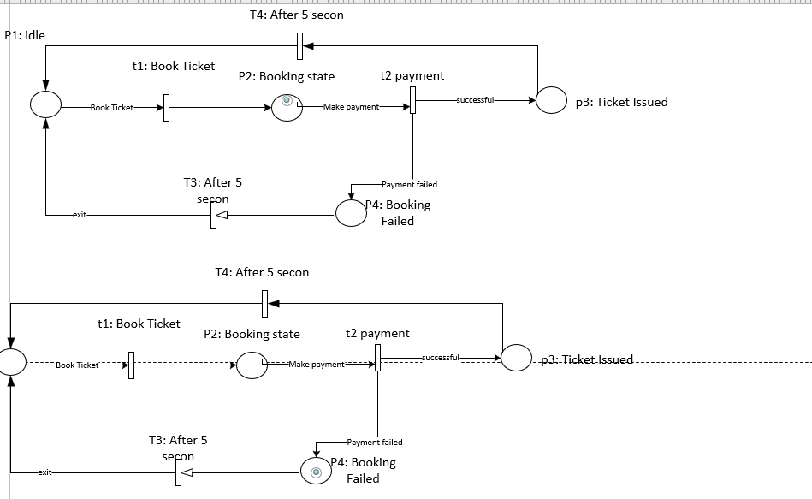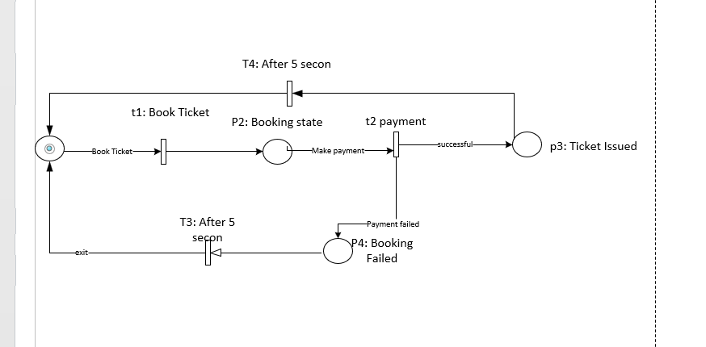

Input output matrix

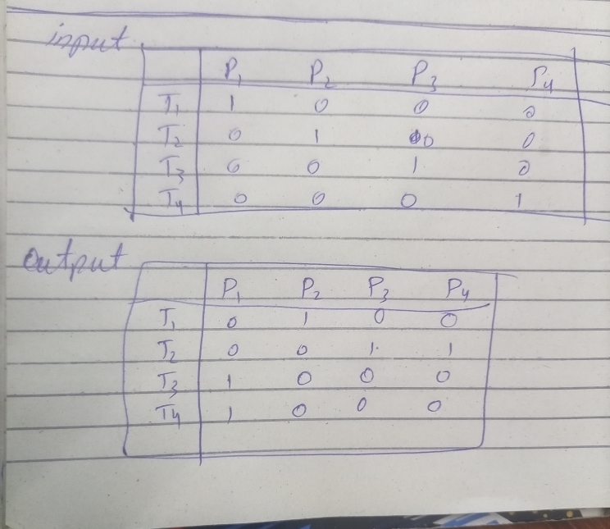
Task 02
Code:

package lab_6;
import java.util.Scanner;
public class SalaryCalculator {
public static void main(String[] args) {
Scanner sc= new Scanner(System.in);
System.out.println("enter No of day:");

float days=sc.nextFloat();

float GrossSalary;
float TaxAmount;
float NetSalary;
if(days>=22&&days<=30) {
GrossSalary=1000*(days*8);
TaxAmount=GrossSalary*4/100;
NetSalary=GrossSalary-TaxAmount;
System.out.println("Permanent Employee\n");

}
else if(days>=10 && days<=21) {
GrossSalary=850*(days*8);
TaxAmount=GrossSalary*6/100;
NetSalary=GrossSalary-TaxAmount;
System.out.println("Contract Employee\n");

}
else {
GrossSalary=700*(days*8);
TaxAmount=GrossSalary*8/100;
NetSalary=GrossSalary-TaxAmount;
System.out.println("Freelance Employee:\n");
}

System.out.println("Gross Salary: "+GrossSalary+"\nTax Amount: "+TaxAmount+"\nNet Salary: "+NetSalary);
}

}

Output
